**Ideation Phase**

**Define the Problem Statements**

|  |  |
| --- | --- |
| Date | JUNE 19 2025 |
| Team ID | LTVIP2025TMID32436 |
| Project Name | TRAFFIC TELLIGENCE |
| Maximum Marks | 2 Marks |

**Customer Problem Statement Template:**

Create a problem statement to understand your customer's point of view. The Customer Problem Statement template helps you focus on what matters to create experiences people will love.

A well-articulated customer problem statement allows you and your team to find the ideal solution for the challenges your customers face. Throughout the process, you’ll also be able to empathize with your customers, which helps you better understand how they perceive your product or service.

Reference: <https://miro.com/templates/customer-problem-statement/>

**Example:**

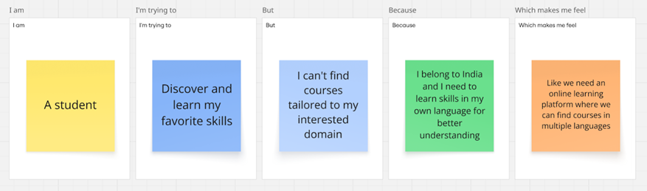

|  |  |  |  |  |  |
| --- | --- | --- | --- | --- | --- |
| **Problem Statement (PS)** | **I am (Customer)** | **I’m trying to** | **But** | **Because** | **Which makes me feel** |
| PS-1 | A college student | To learn how to use modern technology to book my flight tickets | I can’t able to book ticket sbacause it isvery new | I stay in a remote village in India | Like we must have an online learning platform that helps me learn skills I want in language I wish |
| PS-2 | A trainer | Offer helps coding students to develop app for booking flight tickets using latest versions like html,javascipt | Most online learning platforms are charging much | They contain courses created by educators who charge very high | Like we need an online learning platform where individual educators who teach at affordable prices can create courses |

